**TEST PLAN**

1. **Test plan:**

What’s the overall process of collecting bugs?

* + Who are responsible for it?
  + When to do it? Frequency etc
  + Test Setup (People / Computers etc)
  + When to fix bugs?
    - Fix the bugs in pairs

**2) Test cases:**

- what is the scenario?

- what is the error message observed?

- what are the input I have?

Debugging time will be factor in when you do testing or plan another task as debugging time

it is never accurate it’s just estimation.

Prove to supervisor that everything is on time and if he ask to walk through the app, everything must be able to run smoothly.

**Table of Contents**

1. [Objectives](http://sce.uhcl.edu/helm/RUP_course_example/courseregistrationproject/artifacts/test/plans/test_plan_arch.htm#_Toc449511154)
2. [Requirements for Test](http://sce.uhcl.edu/helm/RUP_course_example/courseregistrationproject/artifacts/test/plans/test_plan_arch.htm#_Toc449511157)
3. [Test Strategy](http://sce.uhcl.edu/helm/RUP_course_example/courseregistrationproject/artifacts/test/plans/test_plan_arch.htm#_Toc449511158)
4. [Resources](http://sce.uhcl.edu/helm/RUP_course_example/courseregistrationproject/artifacts/test/plans/test_plan_arch.htm#_Toc449511173)
5. [Project Milestones](http://sce.uhcl.edu/helm/RUP_course_example/courseregistrationproject/artifacts/test/plans/test_plan_arch.htm#_Toc449511176)
6. [Deliverables](http://sce.uhcl.edu/helm/RUP_course_example/courseregistrationproject/artifacts/test/plans/test_plan_arch.htm#_Toc449511177)
7. [Project Tasks](http://sce.uhcl.edu/helm/RUP_course_example/courseregistrationproject/artifacts/test/plans/test_plan_arch.htm#_Toc449511181)

**Test Plan**

**For SLOCA**

**1.****Objectives**

**1.1 Purpose**

This Test Plan describes the plan and overall process of collecting bugs and supports the following objectives:

**Identifying the test strategy to be employed during Unit and Integrated Testing:**

* Test Setup
* Team Member’s responsibilities
* Time Period for bug testing and fixing
* Deliverables for unit and integrated testing
  1. **Scope**

This Test Plan describes the overall strategy during:

* Unit testing after each pair programming task is completed
* Integrated testing following integration and deployment on openshift platform
  + Actual tests cases that will be conducted for each functionality/use case of the SLOCA application.

The following functionalities will be tested:

* + - Login
    - Bootstrap
    - File Upload
    - Basic Location Reports (4 Sub –reports)
    - Group Detection
    - Group Location Reports
    - Json tests
    - UAT automated tests.

**Test Strategy**

**Who’s responsible**

Pair Programmers for each iteration

**Test Setup**

- Pair Programmer team + Chrome + Netbeans + Bug Metrics Document

**When To Log Bugs**

1) Defects/Bugs identified during a running pp session for feature X **should not** be logged by the allocated pair programmers

2) Defects/Bugs identified for **other completed features** during pp session can be logged and included in test cases.

3) During official testing phase.

**What to do with logged bugs**

Update them in the bug metrics

Include them in test cases if the bugs are to be fixed during testing/debugging phase

**When to fix bugs**

Logged bugs should be fixed based on **BUG ASSESSMENT CRITERIA**

**Test tools used**

- Manual Testing conducted during 1st iteration

- Automated Testing software may be used for more complex functionalities and during UAT.

**Test Description & Deliverables**

**UNIT TESTING:**

**Description:**

- Factored in as part of the time required for a PP session

- During this period, identified bugs for the functionality being coded should be fixed.

- If any bugs can’t be fixed by the stipulated time

1. Extend the timing accordingly to ensure completion of the functionality

**Deliverables:**

* + - Bugs for other completed features should be updated in the bug metrics
    - Functionality should be error free after unit testing

**INTEGRATED TESTING:**

**Description:**

* + - Done during Testing phase after integration and deployment

**Pre-Conditions :**

Defects found during integration that **prevent app from running** should already have been fixed

**Deliverables :**

* + - Updated bug metrics ( resolved or not )
    - Updated test cases ( Pass/Fail)

**BUG ASSESSMENT CRITERIA**

Bug Metrics Formula :

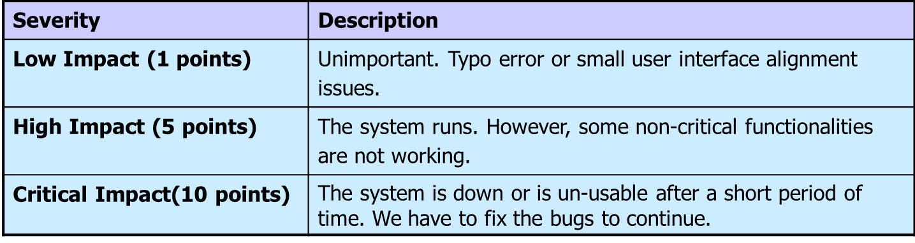

Bug Mitigation Plan:

